MCSE-662 Evolutionary Algorithm

**Assignment 01 : Biomimetics in Home & Around Daily Life;**

# Biomimicry Examples Inspired By Nature



# Introduction:

What is Biomimicry-

Biomimicry involves learning from and mimicking nature to solve architectural design problems and challenges. The aim is to understand in detail what solutions nature has to offer to resolve the problems we face in engineering design and science of materials. It aims to offer an empathic, interconnected understanding of how life works. Biomimicry learns and mimics from the practices and strategies that are used by species to create, design, and process products and policies that solve our greatest design challenges and consequently bring sustainability to our planet. Biomimicry first appeared in scientific literature in 1962. Since then, its usage has grown particularly amongst material scientists. There has been an enormous spike in the interest of architects and engineers regarding biomimicry over the last ten years.

Biomimetic Materials-

Biomimetic materials are materials that are designed in such a way as to replicate the functions and attributes of a material that is produced by living organisms. Biomimetic materials share similar characteristics with biomaterials. The criteria and success of a biomimetic material depend on the fact that they restore natural function and structure without causing any harm.

Biomimetic Architecture-

Biomimetic architecture can be considered as a contemporary philosophy of architecture that seeks to find sustainable solutions by not replicating the natural forms, but rather by understanding the rules of governing those forms. It is a very multi-disciplinary approach towards a sustainable design that follows a set of principles. Biomimetic architecture goes way beyond the use of nature as a source of inspiration for the aesthetic components of built form. It tends to seek nature as a means to resolve architectural problems concerning building various types of structures.

**Shock-absorbing Biomimicry of the Woodpecker:**

Woodpeckers are excellent excavators. They can use their beaks to hunt down insects and create nooks for themselves. As the woodpeckers strike the wood, the head of the bird experiences a deceleration of 1200 gravitational pull 22 times every second. A severe car crash would deliver a deceleration of 120Gs which is nearly fatal and can permanently damage the human brain. But how can a woodpecker absorb almost 10 times more impact force than a car crash? The answer to this is that they have natural shock absorbers. They have a four-structured design which helps them to absorb shock.

They have a semi-elastic beak, an area of spongy bone behind their skull and cerebrospinal fluid; all working in unison to extend the time over which the concussion occurs. This ultimately inhibits vibration. Based on this exquisite design, teams are working to create a wide array of applications to mimic this exceptional anatomy. These include shock-resistant black boxes and micrometeorite resistant spacecraft.

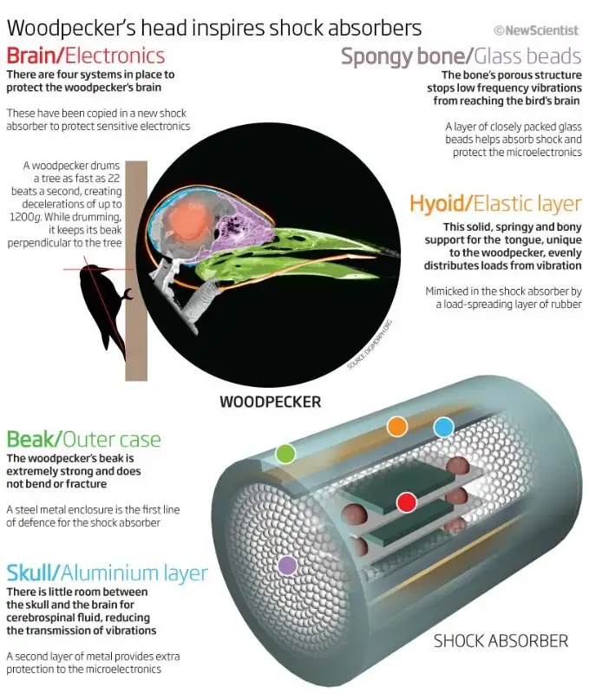

**Termites-inspired Ventilation System:**

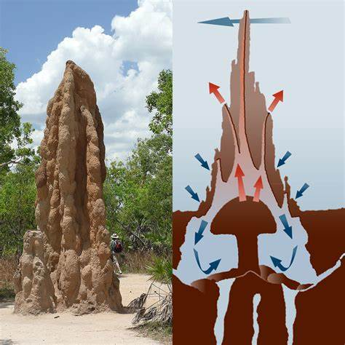

Termites are often considered harmful due to their destructive properties. However, they are known for creating the most elaborate ventilation system for cooling on the planet. Utilizing an intricate network of air pockets, the mounds create a natural ventilation system using convection. An engineering firm built Eastgate center. An entire shopping mall in Harare, Zimbabwe based on this system. The convection system also uses 35% less energy than traditional air-conditioned facilities.

**Water-Harvesting like Stenocara Beetle:**

Water is an important natural resource which is essential for continued life on our planet. Water scarcity is increasingly affecting many parts of the world. Inspiration is available from the Stenocara Beetle. It thrives in the harshest conditions on the planet and may even begin a new generation of clean-water harvesting.

Stenocara Beetle lives in extremely arid regions in the African Namib desert but can pull out water from thin air. The beetle has a pattern of nodes around the back enabling it to collect moisture. The droplets can then slide off into the mouth of the beetle. Newer patents suggest architects are moving to develop biomimetic patterns that are capable of harvesting water from thin air just like the Stenocara Beetle does.

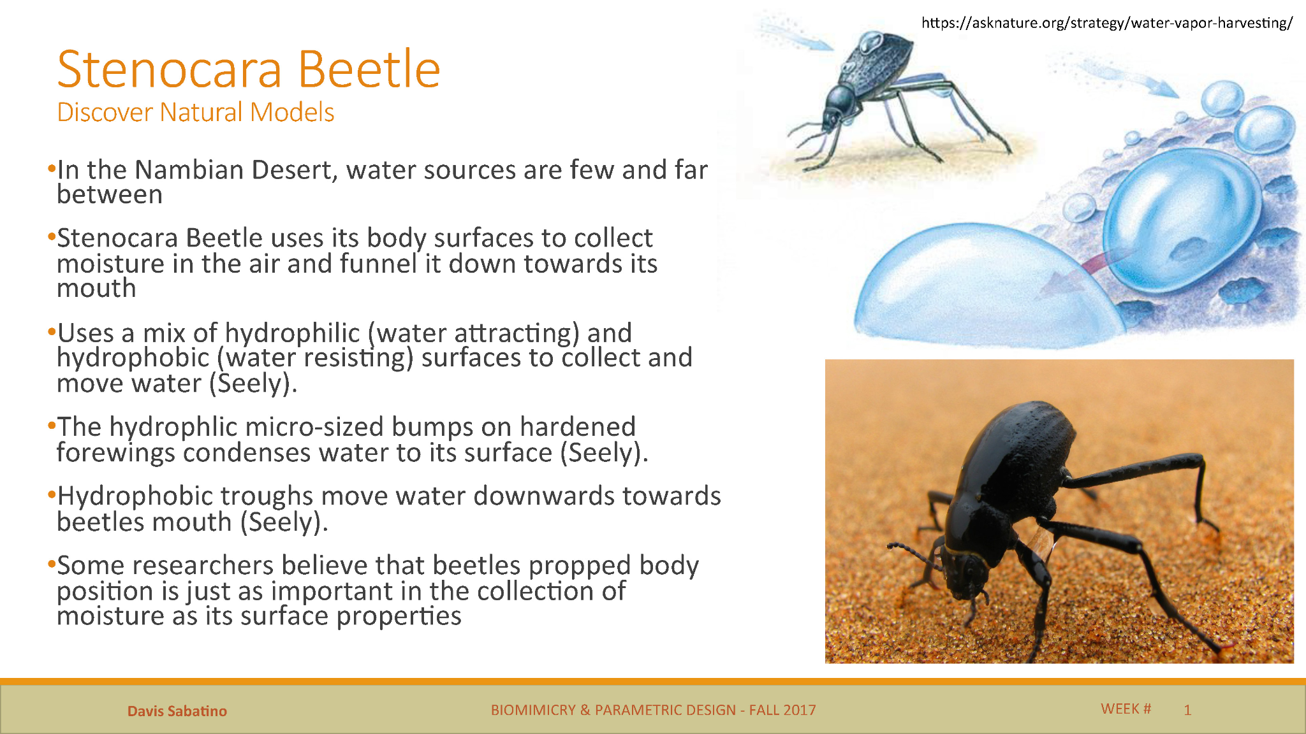

**Antimicrobial & Anti-friction film imitating sharkskin:**

By examining the biological processes of shark skin, NASA scientists were able to copy the microscopic patterns of dentricles to create a ‘riblets’ film. Comparable to shark skin dentricles, this film reduces drag and deters microorganisms (such as algae) attaching to the surface. This was highly advantageous to marine vessels. They can be considered as a flexible layer of small teeth. While in motion, these dermal denticles create low-pressure zones. This pulls the shark forward and reduces the drag during motion. There are plenty of applications to these designs. This model of sharkskin has been incorporated into swimsuit design. Such swimsuits were first used in the 2008 Olympics. The Olympics was won by swimmers who wore this sharkskin swimwear. It made such a big difference that this technology got banned from the Olympics since then. This has led to its further development and utilization in coatings for ship's hulls, submarines, aircraft, and even swimwear for humans. There is also a huge financial incentive, as reducing drag can save thousands of pounds. For instance, researchers estimate that a 1 per cent drag reduction can save one aircraft an approximate 25,000 gallons of fuel per year.

The dermal denticles also prevent growth of microorganisms on the sharkskin, this film reduces drag and deters microorganisms (such as algae) attaching to the surface. Hence, the U.S Navy has made a material, termed as “Sharklet’, which is similar to shark’s skin pattern. It prevents growth of marine life on ship hulls.

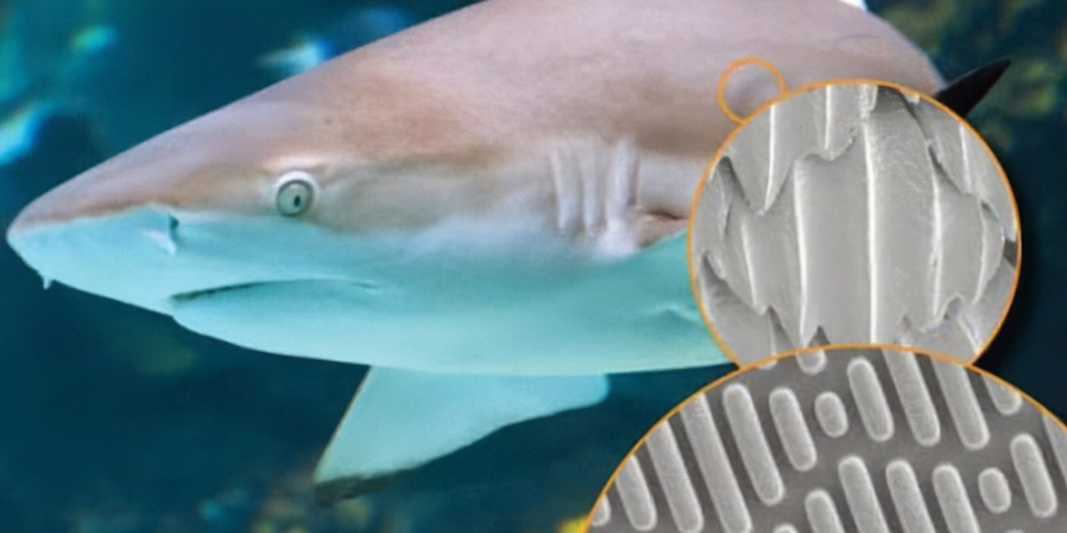

**Armadillo Backpacks and Vests:**

The armadillo has a hide, which is highly rigid and flexible. The hide protects the animal, while enabling it to be agile. Backpacks have been made as people got inspired by this biomimicry. They joined recycled rubber inner tubes around a central axis to make backpacks more adaptable and durable.

Armadillo outer Shell inspired Vest or Protective Armor is also being developed. Greater flexibility and comfort is their advantage. They also provide substantial protection from blunt force trauma, Lightweight and easy access.

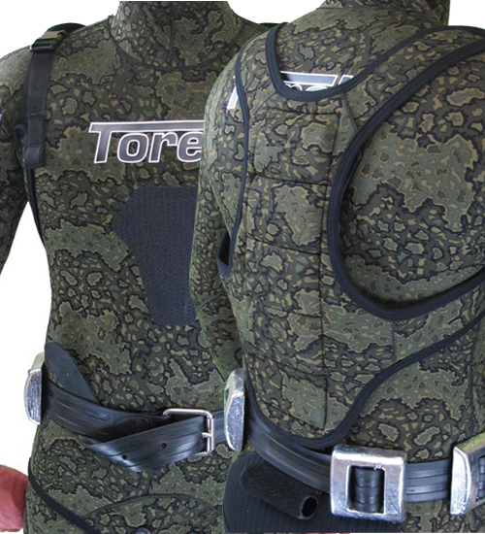

**Turbine Inspired By Whales:**

The humpback whale weighs an astonishing 36 tonnes, yet it is one of the most elegant swimmers, divers and jumpers in the sea. Whales have been swimming in the ocean water since its existence. They can dive hundreds of feet beneath the water and remain there for hours. Their fins help them move from one place to the other. As first researched by Frank Fish, a biomechanic, these aerodynamic abilities are greatly attributed to the bumpy protrusions on the front of its fins, called tubercles. The scientists discovered that the bumps at the front end of the whale help them increase the efficiency, reduce the drag by 32% and increase the lift by 8%. Companies are now trying to apply this idea to the wind turbine and propellers.

Similar to the processes of aircraft wings, whales use their fins at different steepening angles to increase their lift. Too much tilt though, and the opposite will occur and they’ll stall – a loss of lift due to current turbulence and the formation of eddies in the water. By comparing bumpy blades to smooth-edged ones, Fish and colleagues found that stalling occurs at a much higher angle with tubercles – an increase by nearly 40 per cent, in fact. They deduced this higher angle proficiency was beneficial for the whale in allowing it to maneuver in tight circles, hence how they circle and entrap their prey in a ‘net’ of bubbles. Further testing by Fish also revealed that serrated-edge wind turbines proved to be more efficient and quieter than the typical smooth blades. This led to the formation of WhalePower tubercle technology, a company developing a range of tubercle technology products, with a range of blade applications, including wind turbines, hydroelectric turbines, irrigation pumps, ventilation pumps.

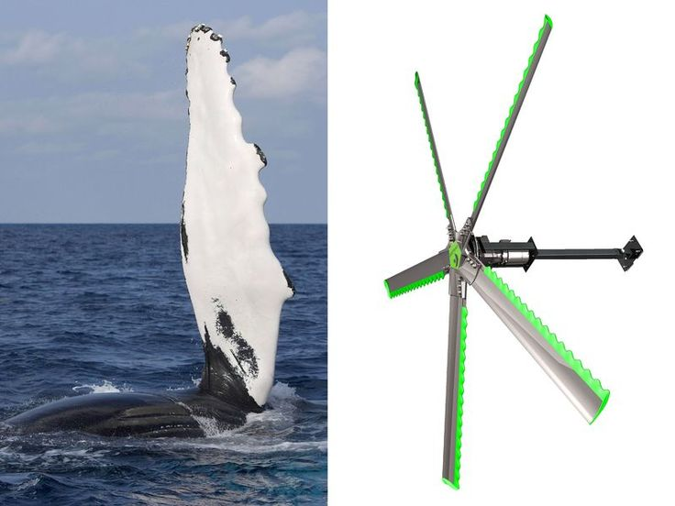

**Bird-safe glass:**

It is estimated that 100 million birds die every year as a result of flying into glass, and the reason is obvious - they simply do not recognise the transparent structure as a physical barrier. To address this problem, a company developed biomimetic Ornilux Birdsafe Glass, drawing inspiration from the UV reflective strands in spider webs, which birds see and therefore avoid. This is a clear mutual benefit for both species, and so Ornilux sought to replicate this with their criss-crossing UV glass.

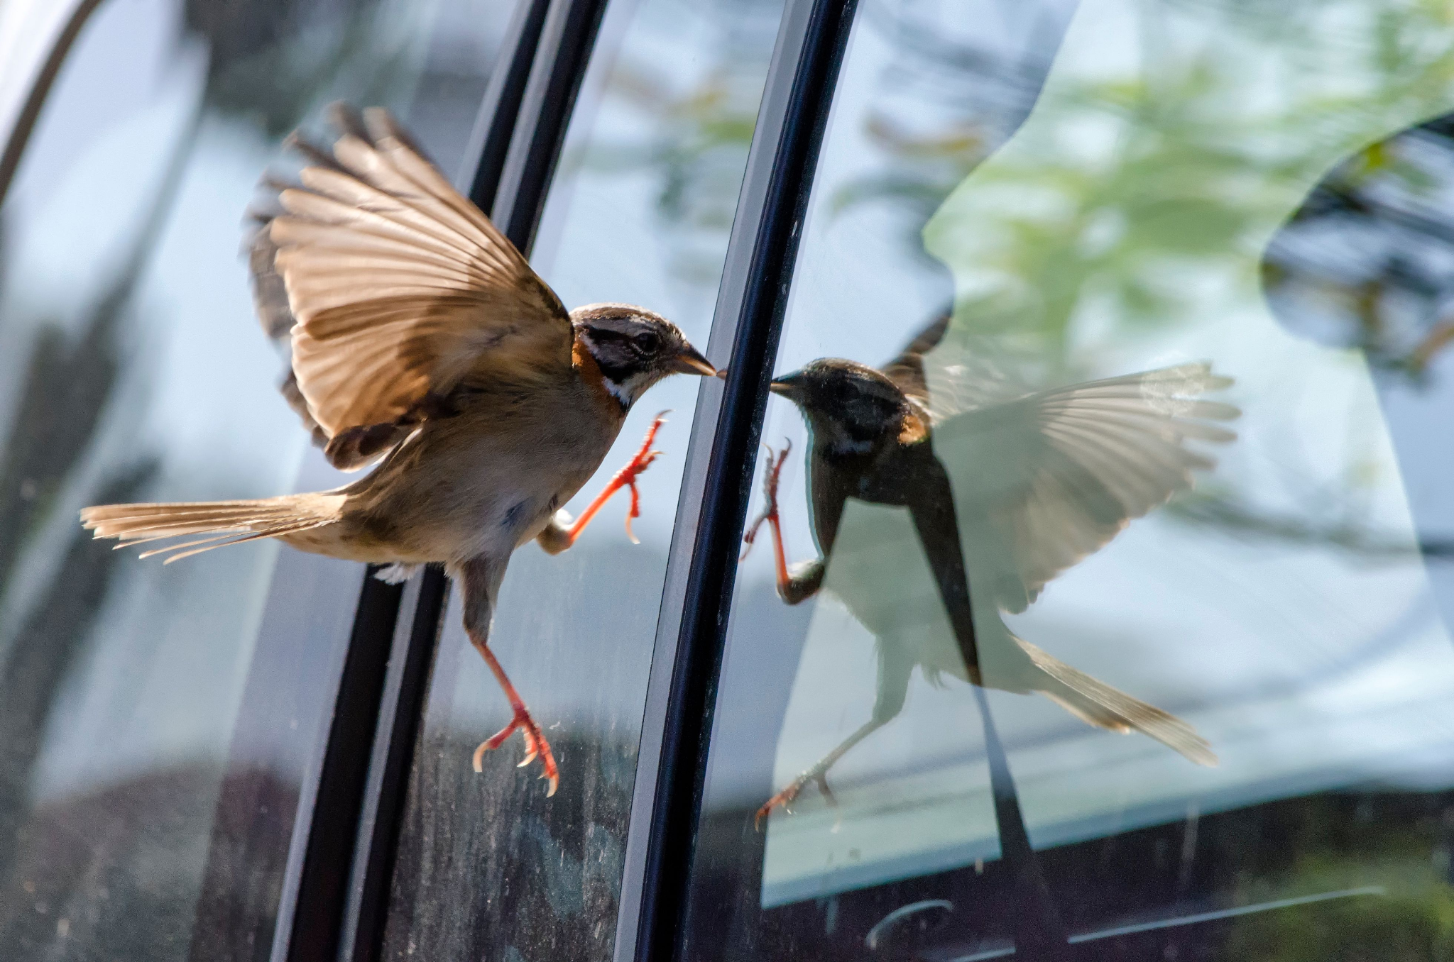

**Box fish and the Bionic car:**

Despite the cumbersome appearance of the boxfish, it has a low flow resistance and a drag coefficient of an astounding 0.06. In comparison, penguins swimming through water have a coefficient of 0.19. In 2005, inspired by the great structural strength and low mass of the boxfish, Mercedes Benz developed the Bionic Car, which reported to reduce drag, have great rigidity, low weight and a significantly lower fuel consumption than traditional cars. Of course just because something seems like the perfect design in the natural world, doesn’t necessarily mean it works out that way in industrial design. You might have noticed the distinct lack of Bionic Car-shaped vehicles on the road, which is probably because a 2015 study found that the shape of the boxfish didn’t reduce drag at all and actually made it more unstable - great for a box fish with 50 million years of evolution to perfect the art of being a boxfish, less good for a people carrier.

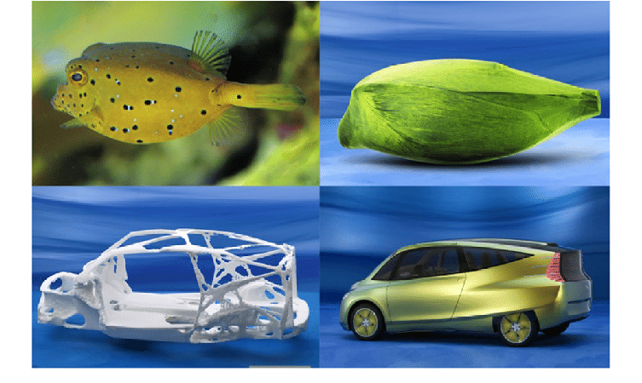

**Velcro:**

George de Mestral was inspired to invent Velcro after noticing how easy it was for burrs to stick to his dog’s hair. Upon studying them under a microscope, he noticed the simple design of tiny hooks at the end of the burr’s spines. These were able to catch anything with a loop, such as fur and fabric, and he went on to replicate this synthetically. His two-part velcro fastening system uses a strip of loosely looping nylon opposite a strip of tiny hooks, and has since been prolific in its range of applications and popularity.

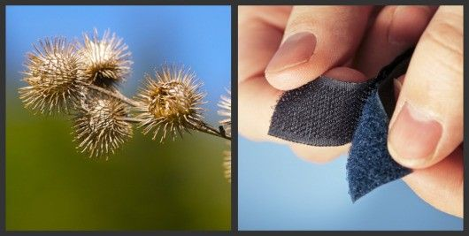

**Birds and flight:**

Perhaps one of the most famous examples of biomimicry is evident in the history of human flight. Leonardo da Vinci is largely recognised as a key instigator in its development, as he made the first real studies on birds and human flight in the 1480s. His original design, called the Ornithopter, was never created, but was a principal in showing how man could potentially fly. Several designers and engineers worked on this bird-inspired concept in the following years, for instance Otto Lilienthal completed more than 2,500 flights in a glider, but it was not until 1903 that the Wright brothers flew the first powered, heavier-than-air machine in a controlled and sustainable flight. This technology went on to define the aerial developments of the 20th century and the technology seen in the air today.

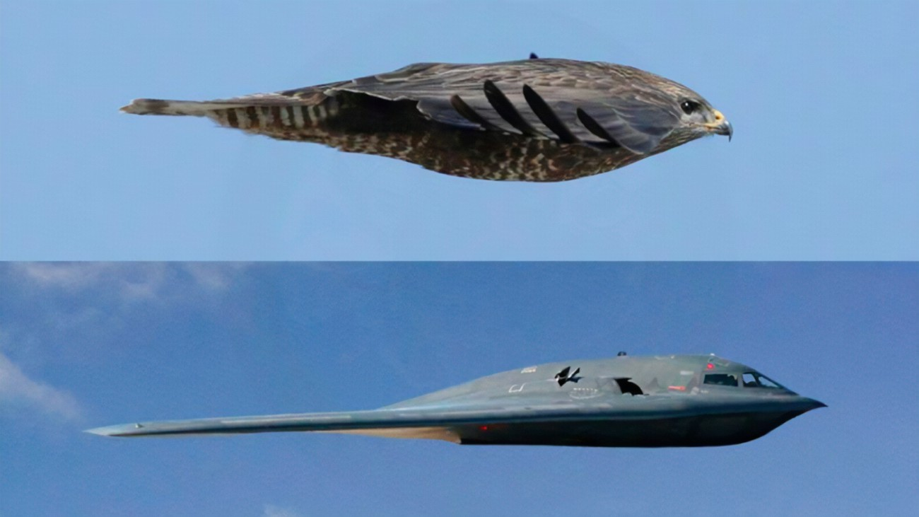

**Lotus-inspired hydrophobia:**

The lotus effect, otherwise known as superhydrophobicity, is the effect seen on the leaves of the Lotus flower, where water is not able to wet the surface and simply rolls off. This high repellency is due to the nanostructure of the plane, where micro-protrusions coated in waxy hydrophobic materials repel the water. This is also a self-cleaning mechanism as dirt particles also stick to the water molecule. Copying this process, CeNano developed nanotol - a hydrophobic (water-repelling), lipophobic (fat-repelling), and oleophobic (oil-repelling) sealant that can be sprayed to substances to create their own superhydrophobicity.

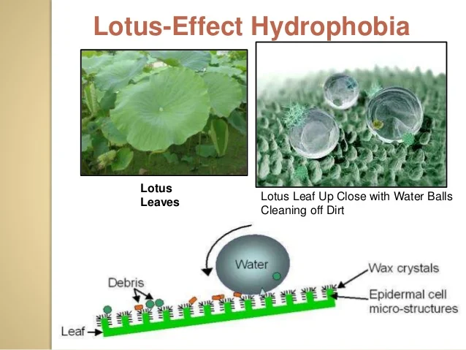

**Lotus flower like paint to repel dust:**

The lotus flower is sort of like the sharkskin of dry land. The flower's micro-rough surface naturally repels dust and dirt particles, keeping its petals sparkling clean. If you've ever looked at a lotus leaf under a microscope, you've seen a sea of tiny nail-like protuberances that can fend off specks of dust. When water rolls over a lotus leaf, it collects anything on the surface, leaving a clean leaf behind. A German company, Ispo, spent four years researching this phenomenon and has developed a paint with similar properties. The micro-rough surface of the paint pushes away dust and dirt, diminishing the need to wash the outside of a house.

**Kingfisher-Inspired Bullet Trains:**

Japanese Engineers took up the daunting tasks of upgrading the high-speed bullet trains. However, they reached a stumbling block concerning the irritating noise created by these trains when they displaced the surrounding air. The trains entering a tunnel would often create a loud shock wave also known as the “tunnel boom”. To reduce the tunnel boom and also prevent structural damage in tunnels, they needed to increase the overall aerodynamics by making the nose of the train more streamlined. The engineers went on to make a train that was modeled like the beak of a Kingfisher bird. The Kingfisher birds have special beaks. These beaks allow them to dive into the water and hunt down their prey without making a splash. After adapting this anatomical trait of the Kingfisher, the next generation of trains proved to be 10 percent faster. Due to streamlined shape, they were also 15% more efficient in terms of electricity use. Most importantly, the new trains didn’t have a “tunnel boom” anymore! Currently, this design has made the Japanese Shinkansen Bullet Train the fastest train in the world, with speeds of up to 200 miles per hour.

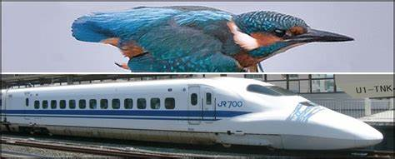

**Mosquitos inspire pain-free micro-needle:**

A new, completely painless, hypodermic microneedle has been developed by engineers in India and Japan. The unique micro-electro-mechanical based suction system has a design that is based on the female mosquito.

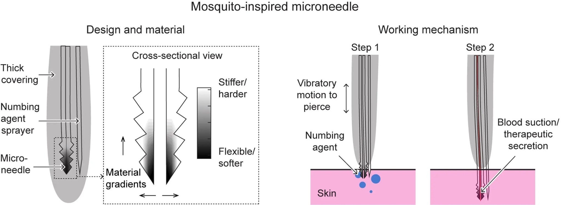

The system uses a sucking motion to draw up blood, similar to the ritual of a mosquito. The needle could be used for various procedures such as drawing blood, injecting drugs and monitoring glucose levels for diabetics.

The needle is strong enough to penetrate as far as 3 millimeters into the skin and reach capillary blood vessels. It has been calculated that this needle can extract 5 microliters of blood per second. Regular needles have a diameter of about 900 microns while this new needle only has a 60 micron diameter.

**Water purification by nature-inspired membrane:**

The biomimetic membrane incorporates aquaporins — membrane proteins that selectively conduct water molecules in and out of cells, preventing the passage of ions and other solutes.

The novel biomimetic membrane can purify water at low pressure, reducing energy costs. It also exhibits high mechanical strength and stability during the water filtration process, making it suitable for industrial applications in water treatment and desalination, noted the release.

According to the university, the new membrane was inspired by the natural water purification systems of the mangrove plant and the human kidney, stated the release. It incorporates aquaporins — membrane proteins that selectively conduct water molecules in and out of cells, preventing the passage of ions and other solutes. With the presence of aquaporin, the mangrove plant is able to filter between 90 and 95 percent of the salt at its roots, while the human kidney is able to purify up to 150 liters of water daily, reported the release.

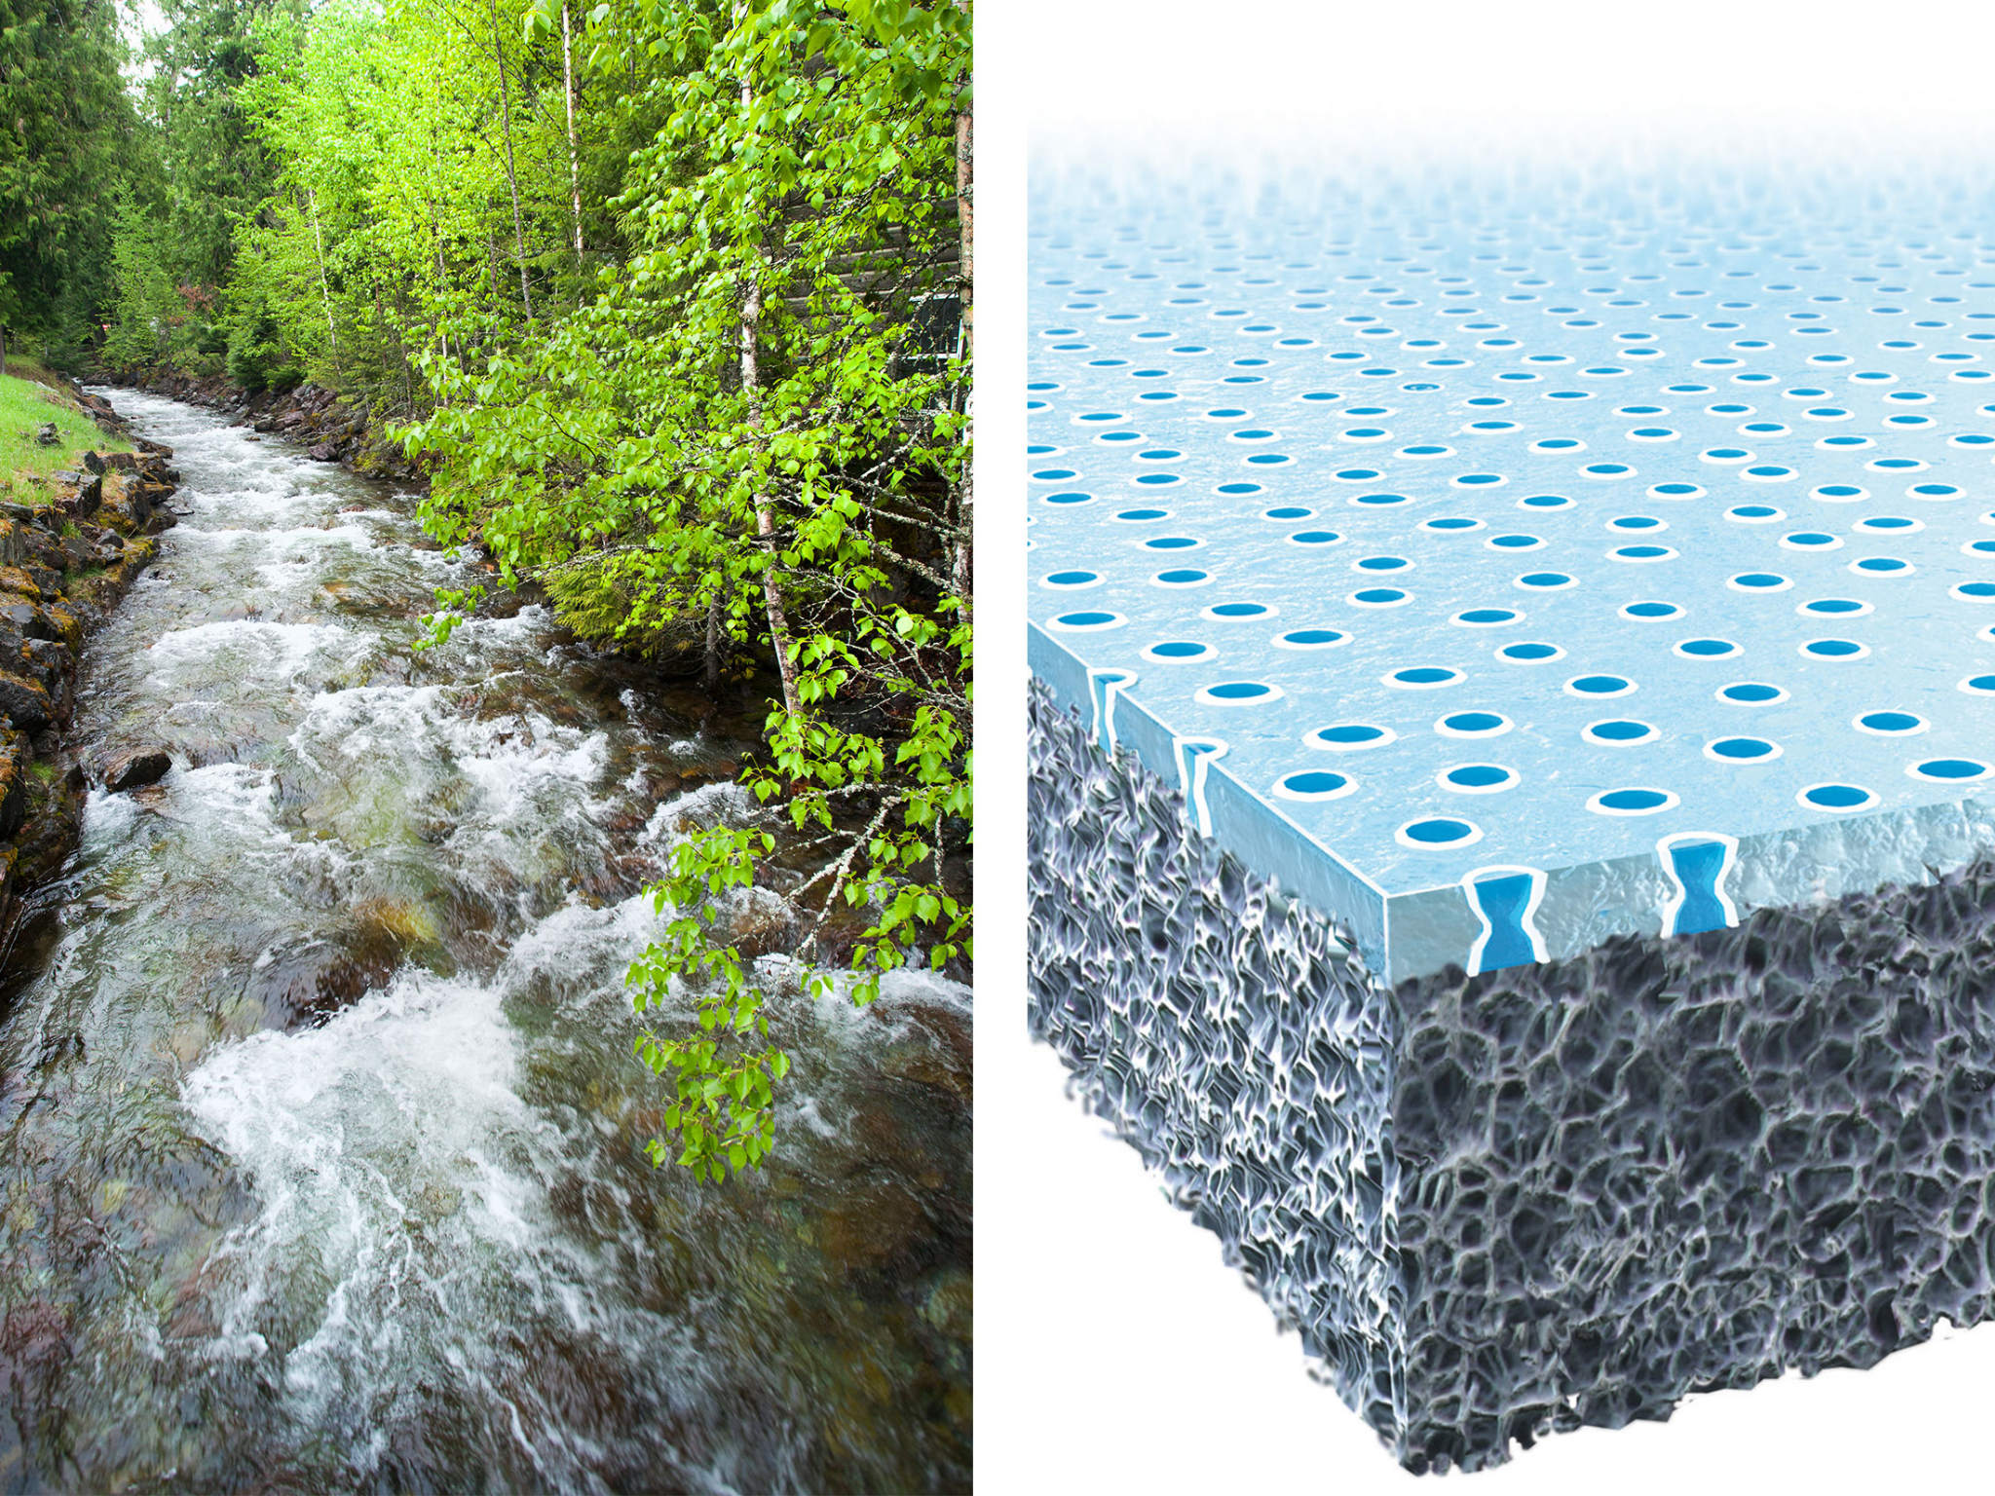

Submitted By- Shied Shahriar Housaini, MCSE 07905536.

[boat shapes inspired by nature - Search (bing.com)](https://www.bing.com/search?q=boat+shapes+inspired+by+nature&FORM=HDRSC1)

[textile weaving inspired by nature - Search (bing.com)](https://www.bing.com/search?q=textile+weaving+inspired+by+nature&qs=n&form=QBRE&sp=-1&pq=textile+weaving+inspired+by+nature&sc=1-34&sk=&cvid=6154586EBA7D466BAECD09918CF93A67&ghsh=0&ghacc=0&ghpl=)

[Inspired by nature: the thrilling new science that could transform medicine | Science | The Guardian](https://www.theguardian.com/science/2016/oct/25/bioinspiration-thrilling-new-science-could-transform-medicine)

[Nature inspired medicine - Search (bing.com)](https://www.bing.com/search?q=Nature+inspired+medicine&form=ANNTH1&refig=42bb7150341346bb87c0d05ac152bcbb)

[natural fertilization - Search (bing.com)](https://www.bing.com/search?q=natural+fertilization&qs=SC&pq=natural+fertilizerat&sc=2-20&cvid=81D1C11E89F643E6B857C93DC0C51F81&FORM=QBRE&sp=1)

[nature inspired cooling - Search (bing.com)](https://www.bing.com/search?q=nature+inspired+cooling&form=ANNTH1&refig=74c96e31daf64e5895108ec826dee078)

[nature inspired refrigeration - Search (bing.com)](https://www.bing.com/search?q=nature+inspired+refrigeration&form=ANNTH1&refig=30273a0dcfd049d4b2885710e83246fd&sp=2&qs=NWU&pq=nature+inspired+refri&sk=PRES1NWU1&sc=8-21&cvid=30273a0dcfd049d4b2885710e83246fd)

[nature inspired irrigation - Search (bing.com)](https://www.bing.com/search?q=nature+inspired+irrigation&form=ANNTH1&refig=f2a7f5b4269b4f679f680f7340221dd1&sp=2&qs=NWU&pq=nature+inspired+irri&sk=PRES1NWU1&sc=7-20&cvid=f2a7f5b4269b4f679f680f7340221dd1)

[water distribution canal system - Search (bing.com)](https://www.bing.com/search?q=water+distribution+canal+system&qs=n&form=QBRE&sp=-1&pq=water+distribution+canal+system&sc=1-31&sk=&cvid=E356BD87C664444D81191204EBCEF002&ghsh=0&ghacc=0&ghpl=)

[water cycle inspired technologies - Search (bing.com)](https://www.bing.com/search?q=water+cycle+inspired+technologies&form=ANNTH1&refig=2e514b68388c43daaaf23ada8fefd25f&sp=1&qs=NWU&pq=water+cycle+inspired+technologie&sk=PRES1&sc=8-32&cvid=2e514b68388c43daaaf23ada8fefd25f)

[medical technologies inspired by nature - Search (bing.com)](https://www.bing.com/search?q=medical+technologies+inspired+by+nature&qs=n&form=QBRE&sp=-1&pq=medical+technologies+inspired+by+nature&sc=1-39&sk=&cvid=4003EF79766D423E9C94E9BDA3EFE676&ghsh=0&ghacc=0&ghpl=)

[Inspired by nature, artificial microtubules can work against a current to transport tiny cargoes (phys.org)](https://phys.org/news/2022-07-nature-artificial-microtubules-current-tiny.html)

[(247) Pinterest](https://www.pinterest.com/sagegreenlife/design-inspired-by-nature/)

[SIX WAYS TO USE NATURE AS YOUR INSPIRATION: LET NATURE BE YOUR MUSE — Pam Ash Designs](https://www.pamashdesigns.com/blog/2016/9/28/ways-to-use-nature-as-your-inspiration)

[Inspired by Nature: Water Treatment Technology Innovations | WaterWorld](https://www.waterworld.com/home/article/16202085/inspired-by-nature-water-treatment-technology-innovations)

[What is the Difference Between Osmosis and Reverse Osmosis? (reverseosmosisdirect.com)](https://reverseosmosisdirect.com/difference-between-osmosis-and-reverse-osmosis/)

[Reverse osmosis - Wikipedia](https://en.wikipedia.org/wiki/Reverse_osmosis)

[Reverse Osmosis inspired by nature - Search (bing.com)](https://www.bing.com/search?q=Reverse+Osmosis+inspired+by+nature&FORM=AWRE)

[Tree roots inspiring Building foundation - Bing images](https://www.bing.com/images/search?q=Tree+roots+inspiring+Building+foundation&form=HDRSC2&first=1&tsc=ImageHoverTitle)

[5 Uses of Honeycomb Sandwich Panels (cacomposites.com)](https://cacomposites.com/news/5-uses-of-honeycomb-sandwich-panels-in-different-areas/)

[IJEDR1504023.pdf](https://ijedr.org/papers/IJEDR1504023.pdf)

[Honeycomb composite structure | OnScale | Inside Simulation](https://onscale.com/blog/honeycomb-composite-structure/)

[Honeycomb composite structure | OnScale | Inside Simulation](https://onscale.com/blog/honeycomb-composite-structure/)

[The Honeycomb Structure | Was It Designed? (jw.org)](https://www.jw.org/en/library/magazines/g201501/honeycomb-structure/)

[Solved: Defining the material properties of the honeycomb core - Autodesk Community - Inventor Nastran](https://forums.autodesk.com/t5/inventor-nastran-forum/defining-the-material-properties-of-the-honeycomb-core/td-p/8940437)

[Honeycomb Structure: its 4 Types, Manufacturing, & Applications (civilclick.com)](https://www.civilclick.com/honeycomb-structure/)

[Honeycomb Structures, Properties and Uses in Composites Manufacturing | APP Knowledge Base (appinc.co)](https://kb.appinc.co/knowledge-base/honeycomb-structures-properties-and-uses/)

[use of honeycomb structure - Search (bing.com)](https://www.bing.com/search?q=use+of+honeycomb+structure&qs=n&form=QBRE&sp=-1&pq=use+of+honeycomb+structure&sc=1-26&sk=&cvid=C7AC82AFC85B416BAF53E8A5BCE74110&ghsh=0&ghacc=0&ghpl=)

[Human-Made Inventions That Already Exist in Nature (businessinsider.com)](https://www.businessinsider.com/6-man-made-inventions-that-already-exist-in-nature-biomimicry-2016-5)

[Velcro: 14 smart inventions inspired by nature - The Economic Times (indiatimes.com)](https://economictimes.indiatimes.com/14-smart-inventions-inspired-by-nature/articleshow/21969336.cms?from=mdr)

[Velcro: 14 smart inventions inspired by nature - The Economic Times (indiatimes.com)](https://economictimes.indiatimes.com/14-smart-inventions-inspired-by-nature/articleshow/21969336.cms)

[14 Smart Inventions Inspired by Nature: Biomimicry - Bloomberg](https://www.bloomberg.com/news/photo-essays/2015-02-23/14-smart-inventions-inspired-by-nature-biomimicry)

[Nature-Inspired Inventions - Kids Discover](https://kidsdiscover.com/teacherresources/nature-inspired-inventions/)

[Nature inspired daily life inventions - Search (bing.com)](https://www.bing.com/search?q=Nature+inspired+daily+life+inventions&FORM=HDRSC1)

[MCSE 07905536 Assignment 01 : Biomimetics in Home & Around Daily Life - Google Docs](https://docs.google.com/document/d/1ioxTuF_a4mh8d00eWydHfmwMRKWXbMEx7ww8TRy6Lx0/edit)